# Improved Learning Management System

Graduation Project

Prepared by:

| * Marwan Tamer Galal | 20200508 |
| --- | --- |
| * Abdelrahman Mohamed Ahmed | 20200318 |
| * Ahmed Mohammed Fayek | 20200043 |
| * David Nael Nady | 20200172 |
| * Mohamed Mahmoud Mohamed | 20200474 |

Under the supervision of

Dr. Iman Helal

Fall 2024

# Index

# 

**Improved Learning Management System 1**

**Index 2**

**Brief of the Project and its vision . 3**

Background 3

Competitors 3

■ Blackboard 3

■ Acadox 3

■ Thinqi 3

■ Google Classroom 3

■ Ain Shams 4

Vision 4

Proposed solutions 4

Leading principals 5

■ User-centric design 5

■ Analytics and reporting 5

Swot Analysis 5

**Analysis Chapter 6**

Data Gathering 6

Survey Structure 6

Analysis Steps 12

Survey Results 14

Project Preliminary Requirements 17

■ Must Have Features 17

■ Should Have Features 18

■ Nice to Have Features 18

**Appendix 19**

Competitor Analysis 19

Student Survey 20

Teacher Survey 20

Responses and data analysis 20

Students Survey Statistics Results 21

■ Blackboard Learn 23

■ Google Classroom Users 26

■ Microsoft Teams Users 29

Initial Requirements 35

# 

# Brief of the Project and its vision.

## Background:

Hybrid learning has become increasingly important since the COVID-19 pandemic began in 2020. To meet this new demand in the market, numerous platforms and applications have emerged to cater to educational institutions, individual trainers, and software companies that create platforms for specific fields of education. Each platform has its unique advantages and disadvantages, but most suffer from issues such as low usability, difficult maintenance, and a focus on specific types of education. Our team recognizes the need for a better platform and has decided to develop one to meet the needs of learners and educators.

## Competitors:

In this section, we will discuss the advantages and disadvantages of some of the most popular e-learning platforms currently available. For the full competitors' Analysis please refer to the index. These platforms include:

### Blackboard:

Blackboard is a very popular e-learning platform that offers a variety of features, including communication tools, course management, and content management. Its advantages include its flexibility and its ability to integrate with various other educational tools. It is extremely versatile due to its many features like video streaming and a mobile app available too. However, its disadvantages include its complexity and the steep learning curve required to use it effectively due to how complicated the interface may be to inexperienced students alongside connection issues that may happen in areas with poor internet connections.

### Acadox:

Acadox is a learning management system that offers features such as course management, assignment submission, and student attendance tracking. Its advantages include its high ease of use and its flexibility. However, its disadvantages include its limited customization options, lack of advanced features and proper marketing with big institutions.

### Thinqi:

Thinqi is a cloud-based e-learning platform that offers features such as course creation, collaboration tools, and learner management. Its advantages include its user-friendly interface and its ability to be customized to fit the needs of specific users. However, its disadvantages include its lack of advanced features and its limited reporting capabilities.

### Google Classroom:

Google Classroom is a free e-learning platform that offers features such as course management, assignment creation, and student progress tracking. Its advantages include its ease of use and its integration with other Google tools. However, its disadvantages include its limited customization options and its lack of advanced features though those disadvantages can be seen as targeting a specific customer profile who needs a simple and lightweight educational platform.

### Ain Shams:

Ain Shams is a popular e-learning platform used by ِAin shams university . Its advantages include its ease of use and its flexibility. However, its disadvantages include its limited customization options and its lack of advanced features.

## Vision:

Our team's vision is to create an e-learning platform that provides a perfect learning environment for students, teaching staff, and management. We aim to create a platform that is easy to use, customizable, and provides all the necessary tools for learners and educators to succeed.

* For students, we envision a platform that acts as their personal repository containing all their studying material and all the tools they need to succeed in their specific field of study.
* For educators, we envision a platform that provides a seamless environment for communication, monitoring, connecting with students, and delivering personalized education. Our platform will allow them to create their personalized classroom with every tool they need to provide the best possible education for their students.
* For management, we aim to provide an analytical platform that enables them to review and evaluate their teaching staff and courses, providing a data-driven approach to decision-making.

## Proposed solutions:

Our team aims to create a platform that provides a better user experience and better maintenance and monitoring for educators. We will focus on addressing the shortcomings of other mainstream platforms.

* + - **The key features of our platform will include:**
* Acting as a material repository for students
* Conducting quizzes and tracking grades
* Providing easy-to-use tools for educators to communicate with students and track their progress.
* Advanced analytics and reporting capabilities that provide insight into student performance, course effectiveness, and learning outcomes.
* Support for mobile learning, allowing students to access content and interact with their instructors on their smartphones and tablets.
* Accessibility features, such as closed captioning, text-to-speech, and other assistive technologies to ensure that all learners have equal access to the content.
* Personalized learning paths and adaptive assessments that provide tailored learning experiences based on individual student needs and abilities.

## Leading principals:

### User-centric design:

Our team is committed to creating a platform that is intuitive, easy to use, and meets the needs of our users. We will prioritize user feedback throughout the development process to ensure that our platform is tailored to the needs of modern learners and educators.

### Analytics and reporting:

Our platform will provide advanced analytics and reporting capabilities that provide insight into student performance, course effectiveness, and learning outcomes. This will enable educators and management to make data-driven decisions and continuously improve the learning experience.

## Swot Analysis:

* + - Strengths:
* User-centric design, with a focus on providing an intuitive and easy-to-use platform for learners, educators, and management.
* Advanced analytics and reporting capabilities that enable data-driven decision-making.
* Support for mobile learning and accessibility features, ensuring that all learners have equal access to the content.
* Personalized learning paths and adaptive assessments, providing tailored learning experiences for individual student needs and abilities.
  + - Weaknesses:
* Lack of brand recognition and reputation, which may make it challenging to attract users in a crowded market.
* The development of advanced features and analytics capabilities may require a significant investment of resources.
* The platform may require ongoing maintenance and updates to ensure that it remains relevant and up-to-date.
  + - Opportunities:
* The growing demand for e-learning platforms due to the COVID-19 pandemic and the increasing importance of online learning.
* The potential to partner with educational institutions and organizations to promote the platform and attract users.
* The potential to expand the platform to include additional features or support for other types of education.
  + - Threats:
* Intense competition from established e-learning platforms that have a strong brand and reputation.
* The risk of security breaches or data loss, which could undermine user confidence in the platform.
* Regulatory and compliance issues that may arise when handling sensitive student data.

# Analysis Chapter

## Data Gathering:

Our vision with this project is to create an LMS that provides an easy and competent environment for students, making them not need that many external tools, for teachers to ease their experience and allows them to provide the most value for students with the least effort and for administrators to easily keep track of the courses, performances and efficiency of their staff. Thus to help direct our project and provide more concrete steps towards those goals, we conducted 2 surveys with the aim of asking students and teachers about their experiences with LMS, their preferred one, the issues they face, and the features they wish to see.

With that in mind, given how we want both the needs of less-experienced stakeholders like our students and extremely experienced stakeholders like teaching staff, we opted to create 2 different surveys. Though both have the same goal, the student version is more quantitative with some supplementary qualitative questions seeking to collect as much data as possible with most questions being Multiple Option Questions and 5-step Likert scale questions starting from 1 (Strongly disagree) till 5 (Strongly Agree). EX: “on a scale from 1 to 5. Please rate this” which allows us to analyse their responses and weight them to notice any inconsistencies or repeated sentiments. For the teachers, we tried to focus on qualitative questions given they are both stakeholders we are less familiar with, given we are students ourselves, and due to their years of experience they would have better awareness and expertise dealing with LMS.

## Survey Structure:

For ease of use, we chose a commonly used form creation tool which is Google Forms and started creating our questionnaire using scale questions, multiple choice and open-ended questions. Due to having a good amount of foreign students at Cairo University, we decided to include an Arabic or English choice for the students to make sure it can be accessible and easy for students who are still learning Arabic

To summarize the questions listed below we will append an abbreviation of the previous question type to each question, so they will be SQ, MCQ, and OEQ respectively with MCQ questions having the options listed immediately below them. And if any question needs explanation or reasoning for it, our thoughts will also be added directly below it. For a full list of all the options please refer to the appendix.

For students, the following were our questions:

1. In which language would you like to view the form questions? (MCQ)
   * Arabic
   * English
2. What is your current university year? (MCQ)
3. What university are you currently attending? (MCQ)

We included all public universities and some of the famous private universities in Egypt amounts to a total of 56 universities and an “Other” option.

1. What is your faculty or area of study? (MCQ)

Similarly to the previous question, we added 24 Common faculties in Egyptian universities with an “other” option.

1. Have you ever used any online learning platform during your university studies? (MCQ)

If yes the student is directed to continue the survey normally. If No and the student never used any LMS, he will be directed to question 26

* + Yes.
  + No.

1. Please specify the platforms you have used (you can select multiple platforms based on your personal usage.) (MCQ)

The provided options were some of the most famous and commonly used tools that have been used for education we are aware of, including all the previously mentioned in the competitors' section like Blackboard, Acadox, and Google Classroom.

Though the term we used encompasses more than just LMS, it is important to see if students already have a tendency to rely solely on LMSs or use supplementary tools alongside them. We included 13 options with an “Other” option, For a full list please refer to the appendix.

1. Among these platforms, please select the platform that you prefer to use primarily. (MCQ. the same options as 6)
2. How frequently do you use the platform? (MCQ)
   * I use it frequently (daily or weekly).
   * I use it moderately (every two weeks or monthly).
   * I use it rarely (only when required).
3. Do you prefer using the platform as a website on your computer or as a mobile app? (MCQ)
   * As a website on my computer.
   * As a mobile application on my smartphone.
   * I prefer using the platform on both computers and smartphones.
   * It doesn't matter to me, I use it on any platform.
4. On a scale of 1 to 10, rate your overall experience with the platform. (SQ)
5. Could you briefly explain the reason behind your rating choice? (OEQ)
6. What are the features/tools that you frequently use on the platform? (You can select multiple answers based on your personal experience.)(MCQ)

The Listed Options are derived from the whole team's experiences using Both LMS and MOOCs to point out the most common tools and features that help us and other individuals through our education journeys.

* + Dashboard and Statistics
  + Learning Content and Course Materials
  + Communication and Discussions
  + Calendar and Assignments
  + Tests and Assessments
  + Virtual Classrooms and Live Lectures
  + Subscriptions and Notifications
  + Interactive Learning and Multimedia Content
  + Blogs and Personal Files (available in Moodle)
  + Student Groups and Collaborative Work (available in Moodle)
  + Reference Materials and Educational Resources (available in Google Classroom)
  + Integration with G-suite like Google Drive and Google Docs (available in Google Classroom)
  + Other (Open-Ended Text Input)

1. Are there any features/tools that you rarely or never use? (You can select multiple answers based on your personal experience.)(MCQ. Same options as 12)
2. Have you encountered any issues or glitches with the platform?
   * Login or password reset issues
   * Difficulty in uploading files or learning materials
   * Slow page loading or connectivity issues
   * Unclear interface or content organization
   * Problems with submitting or receiving assignments
   * Difficulty in communicating with instructors or fellow students
   * Not receiving notifications or updates correctly
   * Issues with viewing recorded lectures
   * Service interruptions or temporary platform downtime
   * I haven't encountered any technical issues.
   * Other (Open-Ended Text Input)
3. On a scale of 1 to 5, rate the performance and speed of the platform. (SQ)
4. On a scale of 1 to 5, rate the features/tools available on the platform. (SQ)
5. On a scale of 1 to 5, rate the user interface of the platform. (SQ)
6. What improvements or changes would you like to see in the platform? (OEQ)
7. What is the most important aspect for you when using an e-learning platform? (MCQ up to 3 options)

The listed options on this question are derived from the competitors' analysis and their advantages

* + Ease of design and usability.
  + Platform organization without the need for an attractive design.
  + Fast and efficient performance regardless of design.
  + Providing a variety of tools and features even if you don't use them all.
  + Attractive design even if it affects some ease of use.
  + Quick access to frequently used tools.
  + Attractive design even if it affects performance speed.

1. What are the aspects that you cannot tolerate in an e-learning platform? (MCQ up to 3 options)

The listed options on this question are derived from the competitors' analysis and their disadvantages

* + Complex or confusing design that is difficult to understand.
  + Unclear organization of content or interface.
  + Slow page loading or connectivity issues.
  + Login or password reset issues.
  + Difficulty in uploading files or learning materials.
  + Problems with submitting or receiving assignments.
  + Difficulty in communicating with instructors or fellow students.
  + Not receiving notifications or updates correctly.
  + Issues with viewing recorded lectures.
  + Service interruptions or temporary platform downtime.

1. Among the following factors, which aspect do you prefer us to prioritize more in the new platform? (MCQ)
   * Performance and speed of the platform.
   * Variety and abundance of tools and features available within the platform.
   * Attractive and interactive user interface.
   * Ease of use and quick access to the desired goals.
2. What are the specific tools you would like to see in the new platform? (OEQ)
3. How do you imagine the ideal e-learning platform? (OEQ)
4. Do you have any suggestions for naming the new platform? (OEQ)
5. Do you have any suggestions for possible colors to be used in the new platform? (OEQ)
6. Do you know what an e-learning platform is? (MCQ)
   * Yes
   * NO
7. Which platform did you hear about? (MCQ, same options as question 6 and can choose multiple options)
8. What did you hear about their usefulness? (OEQ)
9. Any obstacles that may prevent you from using them? Ex: they seem too complicated, not worth the effort, you can't find a way to learn how to use them? (OEQ)

For teachers, the questions were:

1. What is your current job title? (OEQ)
2. How many years of experience do you have in teaching? (OEQ)
3. Which department do you currently work in? (OEQ)
4. Please specify the main courses you teach. (OEQ)
5. Have you used online learning platforms during your teaching tenure at the university? (MCQ)

If No is chosen then the form will be submitted without continuing any further questions.

* + Yes
  + No

1. يرجى تحديد المنصات التعليمية التي استخدمتها خلال سنوات تدريسك؟

(MCQ. can choose multiple options. same options as question 6 from students' survey.)

1. من بين هذه المنصات، أي منصة تعليمية تعتبرها تفضيلك الأول؟

(MCQ. only one option to choose is allowed. Same options as previous question)

1. هل تفضل استخدام المنصة كموقع على الكمبيوتر أم كتطبيق على الهاتف المحمول؟ (MCQ)
   * كموقع على الكمبيوتر.
   * كتطبيق على الهاتف المحمول.
   * أفضل استخدام المنصة على الكمبيوتر والهاتف المحمول على حد سواء.
   * لا يهمني، أستخدمها على أي منصة.
2. لماذا اخترتها كتفضيلك الأول؟ (OEQ)
3. ما هي الميزة / الأداة التي تستخدمها بشكل أكثر في هذه المنصة؟ (OEQ)
4. ما هي المشاكل التي واجهتك خلال استخدامك لهذه المنصة؟ (OEQ)
5. كيف تعاملت مع هذه المشكلة ؟ (OEQ)
6. قيم تجربة استخدامك للمنصة من 5 (SQ)
7. من واقع خبرتك، أي الميزات / الأدوات يجب أن تتوافر في أي منصة تعليمية ولا يمكن التنازل عنها؟ (OEQ)
8. ما هي الميزة / الأداة التي ترغب في وجودها في المنصة التعليمية الجديدة؟ (OEQ)
9. من واقع خبرتك، ما هي المشكلة التي لا يجب أن تحدث في أي منصة تعليمية؟ (OEQ)
10. هل لديك أي ملاحظات ؟ (OEQ)

## 

## 

## Analysis Steps:

To process the data we received and present them into a proper summary report we used excel sheet as it is the format google form outputs. We got the collected data and proceeded to rearrange it into the staging sheet. We used this step to format the responses in a more clear way and prepare for the analysis stage. For the sake of summarisation, we opted to categorize the responses and analyse the responses for the top 3 LMSs which most people have experience using because it implies that those 3 will also have better-educated responses and suggestions.

As pointed out before the student survey is mostly quantitative questions so analysis of their responses took the form of sorting the numerical data for questions with multiple options getting means for scale questions and then visualizing them using charts to show how each option compares to the others and point out clear user preferences and/or characteristics.

For the qualitative questions, we decided to categorize them based on important elements to the users like speed, ease of use, functionality, etc. And picked the most recurring requests in our report for each major LMS.

## 

## Survey Results:

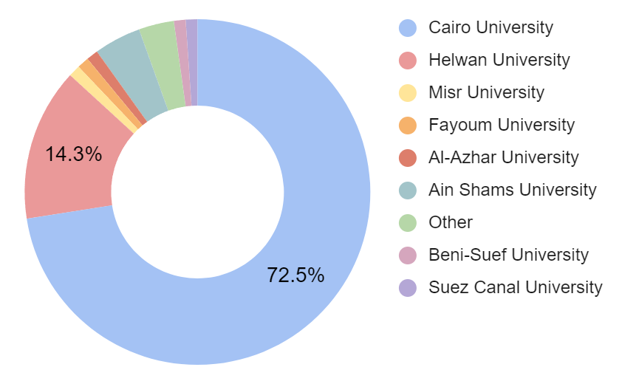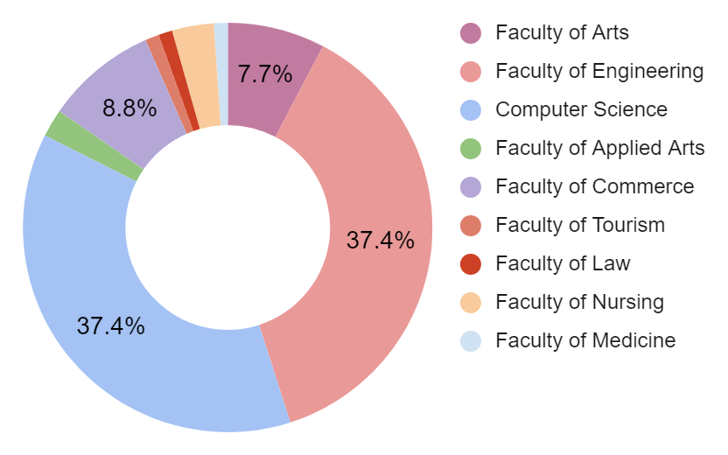

Our survey collected 98 responses from students and all extra details can be found in the full report in the appendix. The students were from various faculties though most of them were from Cairo University and in engineering or computer science faculties. Most of them are in their fourth year and have used an LMS before(95.6%).

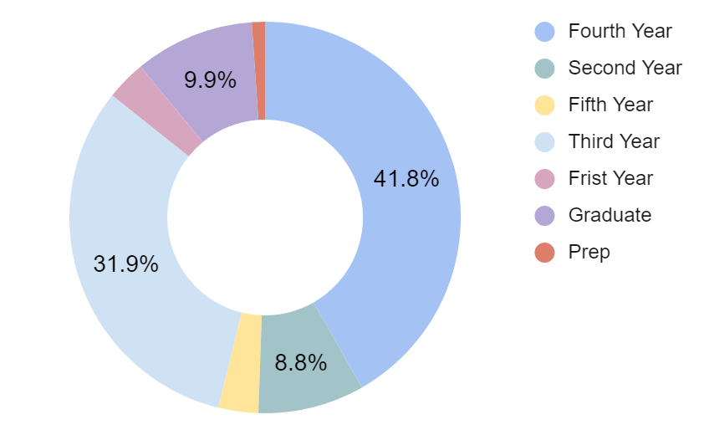

Though the sample size is small, some helpful insights can be gained from the quantitative results alone, as 56.3% said they use both mobile and Web apps and 6.3% rely fully on the LMS mobile app which points out the importance of having an accessible and easy to use mobile application.

The answers to question 8 on the students' survey (how often do you use the LMS) are a bit inconclusive as 40.5% of the respondents said they use it daily and 36.7% said they rarely use it which points out the variance of how students approach using an LMS and using external tools or other sources to study like youtube.

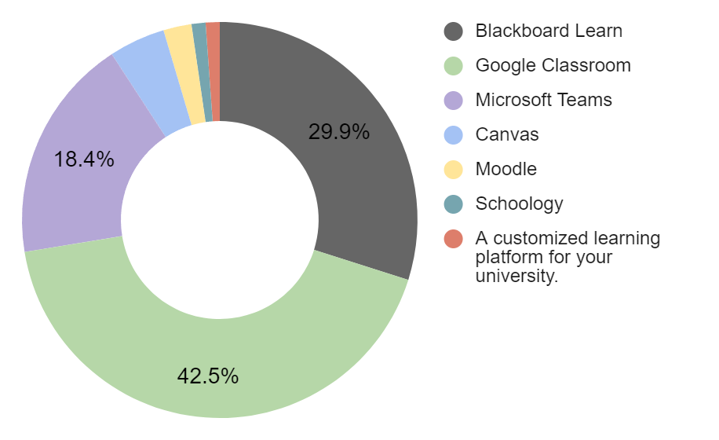

But most important is the usage data on which LMS the students preferred. with Blackboard, Google Classroom, and Microsoft Teams being the top three choices.

On the top is the chart representing the percentages of which LMS the students preferred (Question 7) while below are the cumulative numbers of which LMS the students ever used (Question 6)

It is also crucial to point out a few major points that are derived from this data.

* Firstly, even though Microsoft Teams is not an LMS in the strictest terms, its features of organizing work, dashboards, sharing material and video streaming made it a very useful tool for students and teachers alike.
* Secondly, An interesting note to point out is that 100% of the respondents who chose Blackboard as their preferred LMS were all from Cairo University, adding The fact that most respondents are from Cairo University suggests that the current features of Blackboard are liked enough to warrant a second place even when no other student from another university chose Blackboard.
* Thirdly, This also warrants a deeper look into Google Classroom, as though compared to Blackboard it lacks a lot of the features that allow Blackboard to be an internationally recognized LMS, it is still preferred by many students.
* Lastly, following up on the previous point, even though we added other internationally recognized LMSs like Canvas and Moodle, barely anyone preferred them or even used them. This can be due to our limited respondents but it can also imply a lack of experiments with those LMS in higher education in Egypt.

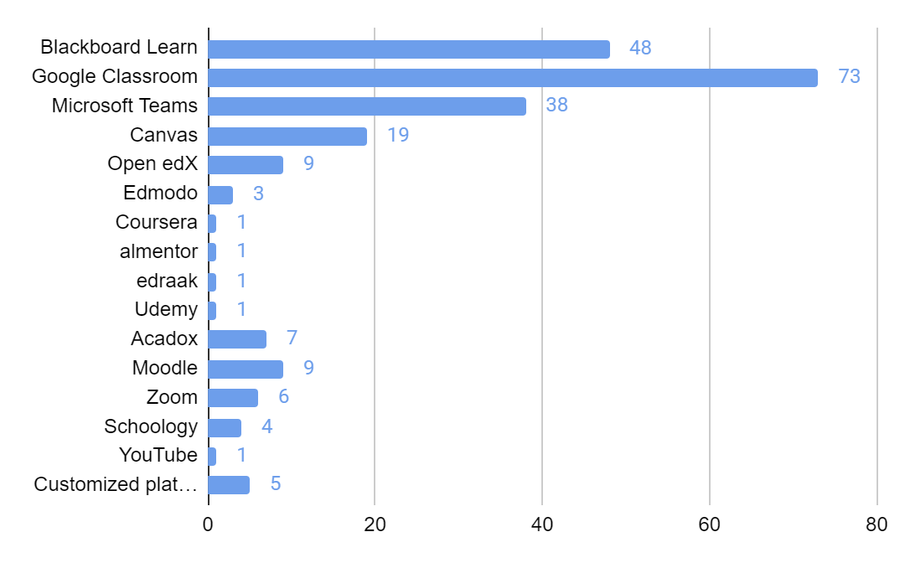

For the teachers' survey sadly we only received 6 responses which is an inadequate number to do a proper data-driven analysis. However, given how most of the questions were qualitative, we can simply screen the responses manually instead of doing deep analysis and categorization.

By going through the responses some common points were made by the teaching staff on how important Ease of use, reusability, of course, issues caused by low bandwidth, sharing and organizing files easier, making quizzes and lastly video conferencing.

## 

## Project Preliminary Requirements:

Per the previous Analysis results, we created a list of requirements/features that should be apparent and focused upon in the project design phases as they can be considered our initial goals and main features till further improvements and adaptations happen. For a full detailed list with explanations for each item please refer to the appendix. The list is split into 3 categories based on priority/importance/Ease of implementation, Those 3 categories.

* Must Have Features: Features that are crucial to the LMS and should not pose significant trouble implementing.
* Should Have Features: Features that include quality-of-life improvements or minor additions to the system as a whole and their implementation may need consideration in the design phase or are easy to implement.
* Nice To Have Features: Features that can benefit stakeholders but are not crucial and their implementation may be extremely complicated and/or require extreme hardware capabilities.

### Must Have Features:

* User Dashboard
* Tracking Course Progress
* Cloud Storage
* Multi-language support ability
* Communication Features
* User-Friendly and easy to navigate Interface
* Accessible interface
* Hot Keys/Quick Access to Tools
* Labels and Categorisation/Platform Organization
* Self Enrollment with invitations or codes
* Create Courses
* Add Material/Reuse material
* Tasks/Assignments
* Writing/Post Editor page
* Quiz assignments
* Mobile App Availability
* Fast Performance
* Blog per Course

### Should Have Features:

* Dark Mode Option
* Youtube video Integration
* SCROM/Xapi/Interopearty Conformance
* Enhanced Search Tools
* Customizable Settings
* Direct File Downloads
* Tutorials
* Improved Notifications
* Efficient File Management
* Integrated External Resources
* Assessment Tools/Teacher Dashboard
* Feedback Mechanisms
* In-depth Analytics

### Nice to Have Features:

* Live Meeting Functionality
* Personalized Learning Paths
* Collaborative Features/ Student teams and shared scores

# Appendix

## Competitor Analysis:

## 

|  | **BlackBoard** | **Moodle** | **Acadox** | **GoogleClassroom** |
| --- | --- | --- | --- | --- |
| **Product** | A traditional LMS focused on meeting institutional needs. It offers extensive customization options, robust analytics, and communication tools. | An open-source LMS, is highly customizable and community-driven. It places emphasis on collaboration, self-directed learning, and support for diverse learning environments. | Acadox provides an integrated platform for educational institutions, aiming to digitize administrative tasks and enhance efficiency. It supports features like course organization, attendance tracking, and file sharing. | Google Classroom, integrated with G Suite, offers a cloud-based platform with user-friendly interfaces and seamless integration with Google products. It emphasizes simplicity, collaborative features, and efficient class management. |
| **Popularity** | High user adoption | Widely used | Moderate user adoption | Widely used |
| **Main Features** | -Course management and delivery  -Collaboration and communication tools  -Assessment and assignment  -management  Mobile app for on-the-go access | -Course management and delivery  -Collaboration and communication tools  -Grading and feedback management  -Mobile app for seamless access | -Course management and administrative  tasks digitization  -Easy access to course materials and  Resources  -Efficient attendance tracking and  management | -Course creation, management, and  Delivery  -Real-time collaboration and  Communication  -Mobile app for easy access and  engagement |
| **Unique Features** | -Extensive customization and integrations  -Collaborative learning features | -Open-source nature allows for  customization and community-driven Development  -Integration with third-party plugins and  tools | -Integration with other educational tools  and systems  -Automated document management | Integration with Google Drive, Docs, and  other G Suite services  -Integration with Google Forms for assessments and quizzes |
| **Product Strengths** | -Established reputation as a traditional  LMS  -Robust analytics and reporting capabilities  -Experience in serving diverse educational institutions | -Supportive of diverse learning environments  -High user satisfaction ratings | -Integrated platform for educational Institutions  -Streamlined user experience with a focus  on efficiency  -Mobile app for convenient usage | - Seamless integration with G Suite and  popular Google products  -User-friendly interface and ease of use  -High user satisfaction ratings |
| **Product Weakness** | -User interface may be less intuitive for some users  -May require additional training for administrators and instructors  -Average rating indicates room for improvement | -User interface may be less intuitive for some users  -Customization may require technical Expertise | -Limited awareness and market penetration compared to competitors  -Average rating indicates room for improvement | -Limited customization options compared  to other competitors  -Reliance on Google ecosystem may limit  integration with other tools |
| **Occasional issues** | -Occasional login issues on the mobile App  -Grading calculation issue in certain  scenarios | -User interface may be less intuitive for some users  -Customization may require technical  expertise | -Limited awareness and market  penetration compared to competitors  -Average rating indicates room for improvement | -Limited customization options compared  to other competitors  -Reliance on Google ecosystem may limit  integration with other tools |
| **What users Like** | -Customization options | -Flexibility and customization | -Streamlined administrative tasks | -Integration with Google services and ease of use |
| **What users Dislike** | -User interface can be complex | -Technical expertise required for customization | -Limited awareness and user base | -Limited customization options |

## 

## Student Survey:

For the full transcript please refer to the Appendix folder attached to this document, a PDF Form of the survey should exist there.

## Teacher Survey:

For the full transcript please refer to the Appendix folder attached to this document, a PDF Form of the survey should exist there.

## Responses and data analysis:

For the full transcript please refer to the Appendix folder attached to this document, an excel sheet with the results and analysis steps should exist there.

## 

## Students Survey Statistics Results:

Total Participants: 98

General Info “Quantitative”

1. In which language would you like to view the form questions?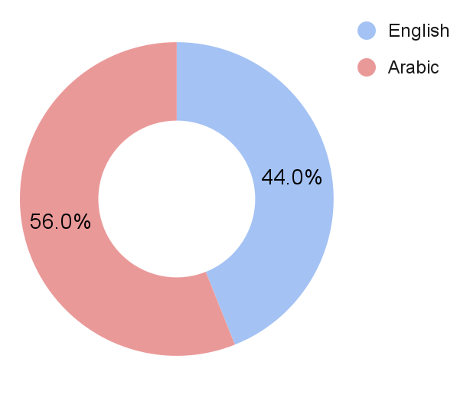
2. What is your current university year?

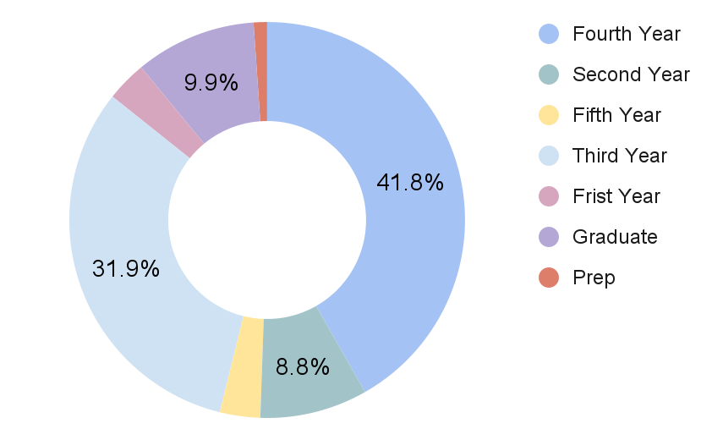

1. What university are you currently attending?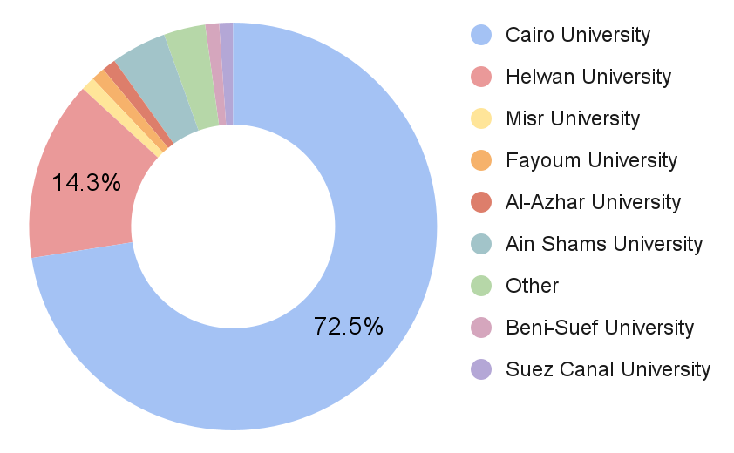
2. What is your faculty or area of study?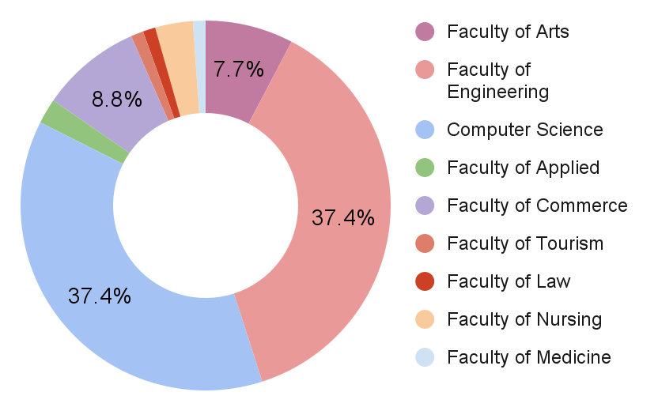
3. Have you ever used any online learning platform during your university studies?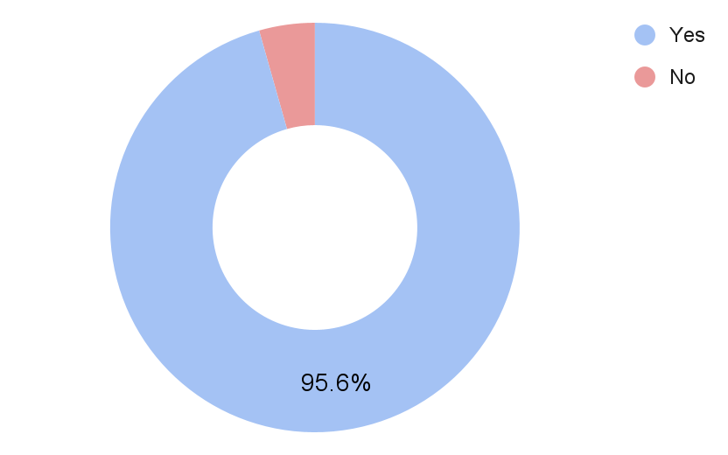

Usage of E-Learning Platforms in Higher Education

1. Please specify the platforms you have used ( you can select multiple platforms based on your personal usage ).

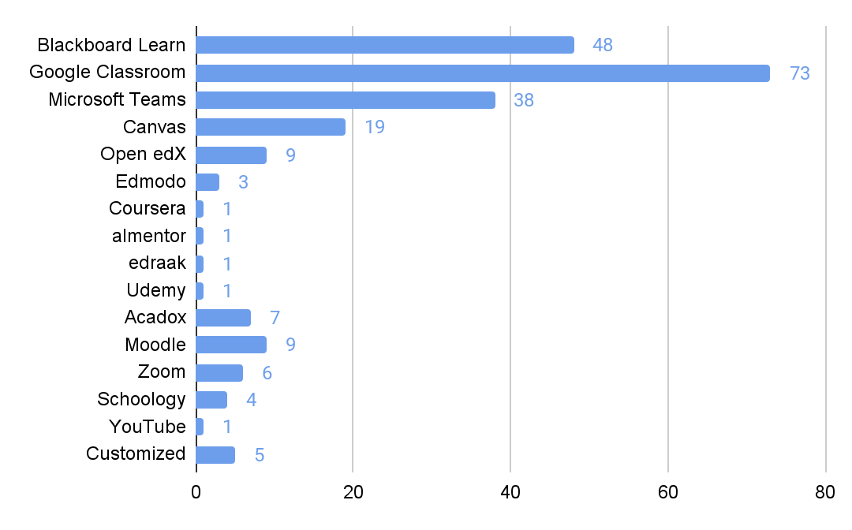

1. Among these platforms, please select the platform that you prefer to use primarily.

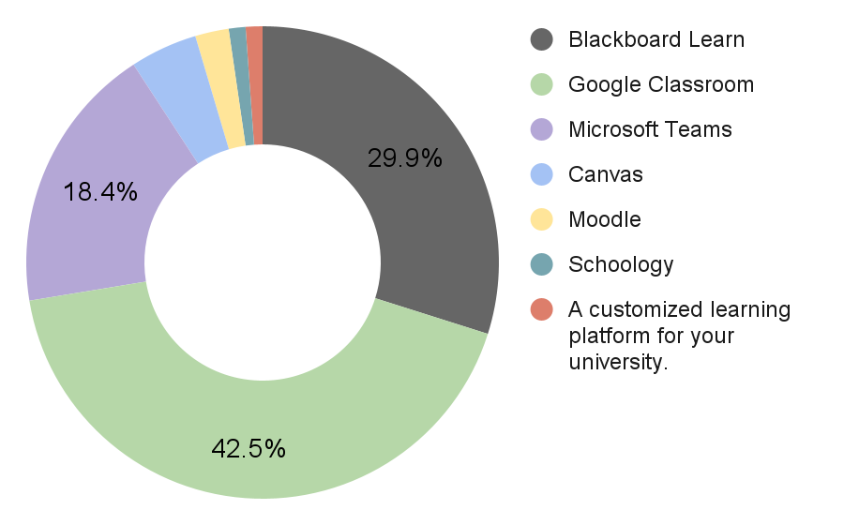

## 

## Blackboard Learn:

1. On a scale of 1 to 10, rate your overall experience with the platform?

* Based on the responses, the ratings range from 4 to 10, with an average rating of approximately 7.8.

1. Could you briefly explain the reason behind your rating choice?

* Based on the provided explanations for the ratings of Blackboard Learn, here is a summary of the reasons behind the rating choices:

Positive aspects:

* Blackboard Learn allows for uninterrupted lectures and provides the option to save recorded lectures.
* The platform is comprehensive and consolidates course content in one place.
* It is user-friendly and easy to navigate.
* It offers features such as meetings, grades, and exams.
* It is stable, easy to use, and has integrated features.
* It helps in organizing educational materials and recorded lectures.
* It saved a significant amount of time and facilitated learning.

Negative aspects:

* The user interface (UI) can be complex or messy for some users.
* There are occasional technical issues during online quizzes.
* Some desired functionalities are missing.
* It may be unavailable or restricted to specific universities.
* It can be clunky or difficult to use at times.
* There were complications with streaming and curriculum collection.

Some students experienced problems during enrollment due to codes or restrictions.

SWOT Analysis for Blackboard Learn:

Strengths:

* Uninterrupted lectures and the option to save recorded lectures.
* Comprehensive platform that consolidates course content in one place.
* User-friendly interface and easy navigation.
* Offers essential features like meetings, grades, and exams.
* Stable, easy to use, and integrated features.
* Aids in organizing educational materials and recorded lectures.
* Saves time and facilitates learning.

Weaknesses:

* Complex or messy user interface for some users.
* Occasional technical issues during online quizzes.
* Missing desired functionalities.
* Limited availability or restrictions to specific universities.

Opportunities:

* Addressing the user interface issues to improve overall user experience.
* Resolving technical glitches and enhancing platform performance.
* Incorporating additional features to meet diverse educational needs.
* Expanding availability to reach a broader user base.

Threats:

* Competition from other e-learning platforms.
* Negative user experiences leading to reduced adoption.
* Technological disruptions impacting platform usability.

1. On a scale of 1 to 5, rate the performance and speed of the platform.

* Based on the responses, the ratings range from 2 to 5, with an average rating of approximately 3.5.

These ratings suggest that the majority of students perceive the performance and speed of the platform as satisfactory, with some room for improvement.

Understanding the user perception of the platform's performance and speed helps in identifying areas that may require optimization to ensure a smoother and more efficient user experience.

1. On a scale of 1 to 5, rate the features/tools available on the platform.

* Based on the responses, the ratings range from 3 to 5, with an average rating of approximately 4.

These ratings indicate that the majority of students perceive the features/tools available on the platform as satisfactory to good.

Understanding the user perception of the available features/tools helps in identifying their effectiveness and areas that may require enhancement or additional functionalities to better support the learning process.

1. On a scale of 1 to 5, rate the user interface of the platform.

* Based on the responses, the ratings range from 2 to 5, with an average rating of approximately 3.7.

These ratings suggest that the user interface of the platform is generally perceived as average to good, with some room for improvement.

Understanding the user perception of the user interface helps in identifying areas that may require enhancement to improve the usability, clarity, and overall user experience.

1. What improvements or changes would you like to see in the platform?

* Based on the responses, here are some common themes:
* Improved communication features: Some users expressed a desire for better communication channels between students, instructors, and administrators, allowing for easier interaction and discussions related to course content.
* Easier navigation and user interface: Several users mentioned the need for a more user-friendly interface, with simplified navigation and a cleaner layout to reduce clutter and enhance the overall user experience.
* Enhanced speed and performance: A few users highlighted the importance of improving the platform's speed and performance, ensuring smooth and efficient usage.
* Accessibility and availability: Some users expressed a desire for the platform to be freely accessible to all users and available for use by everyone, suggesting the importance of inclusivity.
* Clear instructions and tutorials: A few users mentioned the need for clear instructions and tutorials, particularly regarding the registration process, connectivity issues, and how to access and complete assignments.
* Improved video streaming and quality: Some users requested improvements in the quality of online lectures, better video streaming, and enhanced connectivity to ensure a seamless learning experience.

## Google Classroom Users

1. On a scale of 1 to 10, rate your overall experience with the platform?

* Based on the responses, the ratings range from 7 and 10, with an average rating of approximately 8.54.

1. Could you briefly explain the reason behind your rating choice?

* Based on the comments, we can identify several reasons behind the rating choices for the overall experience with Google Classroom. Here are the key points:

Positive aspects:

* Ease of use: Users find Google Classroom easy to navigate and utilize without requiring extensive explanation or training.
* Communication: The platform facilitates communication between students and teachers, allowing for messaging and task reminders before deadlines.
* Organization: Users appreciate the organizational features of Google Classroom, such as task tracking, submission dates, and easy access to learning materials.
* Integration with Google Drive: The seamless integration with Google Drive allows for easy access to and storage of learning materials.

Negative aspects:

* Lack of live meetings: Some users mention the absence of live meeting functionality within Google Classroom as a drawback.
* File download limitations: Users note that direct file downloads to their devices are not readily available and require specific methods.
* Communication issues: Some users mention challenges in communication between instructors, indicating that the platform's communication features may need improvement.
* Notification issues: Occasionally, users report issues with notifications not being received promptly or consistently.
* Desired features: Users express a desire for additional features, such as dark theme support, support for quizzes, improved separation between teacher and student posts, and enhanced meeting capabilities.

Overall, the majority of users find Google Classroom easy to use, efficient, and helpful for organizing their academic activities. However, there are suggestions for improvements and the addition of certain features to enhance the platform's functionality.

SWOT Analysis for Google Classroom:

Strengths:

* Ease of use and user-friendly interface.
* Effective communication features between students and teachers.
* Organizational tools for task tracking and submission dates.
* Seamless integration with Google Drive for easy access to learning materials.
* High overall user satisfaction, with an average rating of 8.54 out of 10.

Weaknesses:

* Lack of live meetings functionality within the platform.
* Some users face challenges with file download limitations.
* Communication features may need improvement based on user feedback.
* Occasional notification issues impacting timely updates.

Opportunities:

* Introducing live meeting capabilities to enhance real-time interaction.
* Improving file download processes for a smoother user experience.
* Refining communication features to address user concerns.
* Enhancing notification systems for more reliable and timely updates.
* Adding desired features like dark theme support, support for quizzes, and improved post separation.

Threats:

* Competition from other e-learning platforms offering similar functionalities.
* Potential user dissatisfaction if identified weaknesses are not addressed.
* Technological disruptions affecting platform performance and reliability.

1. On a scale of 1 to 5, rate the performance and speed of the platform.

* The average rating based on the responses is approximately 4.14, indicating a generally positive perception of the platform's performance and speed.

1. On a scale of 1 to 5, rate the features/tools available on the platform.

* Based on the responses, the ratings for the available features and tools range from 1 and 5, with an average rating of approximately 3.77.

1. On a scale of 1 to 5, rate the user interface of the platform.

* Based on the responses, the ratings for the User Interface range from 1 and 5, with an average rating of approximately 3.67.

1. What improvements or changes would you like to see in the platform?

Based on the feedback provided, users have expressed various suggestions and improvements they would like to see in the platform. Some of the common suggestions include:

* Improved Communication: Easier and more direct communication with supervisors or instructors.
* User Interface: Making the interface more user-friendly and familiar, possibly by adopting elements from well-known platforms like Facebook, WhatsApp, or YouTube.
* Better Organization: Implementing clearer organization, such as having organized folders within each course or subject.
* Direct Downloading: Allowing direct downloads similar to Google Drive, without the need to go to another platform.
* Dark Mode: Adding a dark mode option for improved readability and reduced eye strain.
* Enhanced Search Tools: Incorporating additional tools to help users find specific content more easily.
* Online Meetings: Introducing the ability to conduct online meetings within the platform.
* More Features and Settings: Providing more customizable features and settings to tweak the user interface.
* Simplicity and Clarity: Simplifying the platform for better usability and clearer navigation.
* Improved Recordings and Live Sessions: Enhancing the quality and features of recorded lectures and live sessions.

It's important to note that these suggestions come from individual users with their unique perspectives and preferences. Implementing changes to the platform would require careful consideration by the platform's developers, taking into account user feedback and the platform's overall goals and capabilities.

## Microsoft Teams Users

1. On a scale of 1 to 10, rate your overall experience with the platform?

* Based on the responses, the ratings range from 7 and 10, with an average rating of approximately 8.54.

1. Could you briefly explain the reason behind your rating choice?

* Based on the comments, we can identify several reasons behind the rating choices for the overall experience with Google Classroom. Here are the key points:

Positive aspects:

* Ease of use: Users find Google Classroom easy to navigate and utilize without requiring extensive explanation or training.

Negative aspects:

* Lack of live meetings: Some users mention the absence of live meeting functionality within Google Classroom as a drawback.

Overall, the majority of users find Google Classroom easy to use, efficient, and helpful for organizing their academic activities. However, there are suggestions for improvements and the addition of certain features to enhance the platform's functionality.

SWOT Analysis for Microsoft Teams:

Strengths:

* Ease of use and user-friendly interface.

Weaknesses:

* Lack of live meetings functionality within the platform.

Opportunities:

* Introducing live meeting capabilities to enhance real-time interaction.

Threats:

* Competition from other e-learning platforms offering similar functionalities.

1. On a scale of 1 to 5, rate the performance and speed of the platform.

* The average rating based on the responses is approximately 4.14, indicating a generally positive perception of the platform's performance and speed.

1. On a scale of 1 to 5, rate the features/tools available on the platform.

* Based on the responses, the ratings for the available features and tools range from 1 and 5, with an average rating of approximately 3.77.

1. On a scale of 1 to 5, rate the user interface of the platform.

* Based on the responses, the ratings for the User Interface range from 1 and 5, with an average rating of approximately 3.67.

1. What improvements or changes would you like to see in the platform?

Based on the feedback provided, users have expressed various suggestions and improvements they would like to see in the platform. Some of the common suggestions include:

* Improved Communication: Easier and more direct communication with supervisors or instructors.

1. On a scale of 1 to 10, rate your overall experience with the platform?

* Based on the responses provided, the ratings for the overall experience with Microsoft Teams platform range from 4 to 10, with an average rating of approximately 7.73.

1. Could you briefly explain the reason behind your rating choice?

* Based on the comments, we can identify several reasons behind the rating choices for the overall experience with Microsoft Teams. Here are the key points:

Positive aspects:

* Easy to use, clear, and simple interface.
* Availability of desired features and easy communication options.
* User-friendly design, easy to understand, and comfortable to work with on both computers and mobile devices.
* Simple platform with no complications.
* Effective meeting quality and chat functionality.
* Organized and straightforward in its approach.
* Good performance without frequent disconnections or interruptions.

Negative aspects:

* Occasional login issues and disruptions in connectivity.
* Some users experienced lags and slow loading times.
* Occasional errors and issues.
* Share screen function not working well, and slow performance at times.
* Internet-related problems causing occasional disruptions.

Overall, Microsoft Teams is praised for its ease of use, user-friendly interface, and effective communication features. However, occasional technical issues and connectivity problems were some of the areas that affected the overall experience for a few users.

SWOT Analysis for Microsoft Teams:

Strengths:

* Easy to use, clear, and simple interface.
* Availability of desired features and easy communication options.
* User-friendly design, comfortable to work with on both computers and mobile devices.
* Organized and straightforward in its approach.
* Effective meeting quality and chat functionality.
* Good performance without frequent disconnections or interruptions.

Weaknesses:

* Occasional login issues and disruptions in connectivity.
* Some users experienced lags and slow loading times.
* Occasional errors and issues.
* Share screen function not working well, and slow performance at times.
* Internet-related problems causing occasional disruptions.

Opportunities:

* Addressing technical issues to improve overall platform stability and performance.
* Implementing UI enhancements based on user feedback to increase usability.
* Optimizing the platform to work efficiently on low-spec devices.
* Improving file upload and download speed and communication during lectures.
* Enhancing video quality and additional functionality like screenshot capabilities.

Threats:

* Competition from other collaboration and communication platforms.
* User dissatisfaction leading to reduced adoption and engagement.
* Technical disruptions impacting platform reliability and user experience.

1. On a scale of 1 to 5, rate the performance and speed of the platform.

* Based on the responses, the ratings for the performance and speed of the platform range from 2 to 5, with an average rating of approximately 3.71.

1. On a scale of 1 to 5, rate the features/tools available on the platform.

* Based on the responses, the ratings for the available features and tools on the platform range from 3 to 5, with an average rating of approximately 4.06.

1. On a scale of 1 to 5, rate the user interface of the platform.

* Based on the responses, the User Interface (UI), the ratings range from 3 to 5, with an average rating of approximately 4.27.

1. What improvements or changes would you like to see in the platform?

Based on the responses, users would like to see the following improvements or changes in the platform:

* Faster speed and improved performance to avoid frequent issues and interruptions.
* Better user interface (UI) with some changes to enhance usability.
* Addressing the problem of slow file upload and download, as well as difficulties in communication during lectures.
* Improvements in video quality and the ability to take screenshots.
* Optimizing the platform to work efficiently on low-spec devices.
* Increased attention to assignments.
* No specific improvements requested by some users.

Overall, users seem to value a smoother and more efficient experience with the platform, focusing on speed, UI enhancements, and better functionality for their learning needs.

1. What is the most important aspect for you when using an e-learning platform?

* Based on the responses provided, the most important aspect when using an e-learning platform seems to be a combination of the following factors:
* Fast and efficient performance: Users prioritize the platform's speed and effectiveness, regardless of its design.
* Ease of design and usability: Users value a platform that is easy to navigate, intuitive, and user-friendly.
* Quick access to frequently used tools: Users appreciate the ability to easily and quickly access the tools and features they frequently use.
* Platform organization: Users prefer a well-organized platform that doesn't necessarily prioritize attractive design over functionality.

These aspects highlight the importance of a smooth user experience, efficient functionality, and convenient access to tools and features. Keep in mind that individual preferences may vary, and different users may have different priorities when it comes to e-learning platforms.

1. What are the aspects that you cannot tolerate in an e-learning platform?

* Based on the responses provided, that are generally not tolerated in an e-learning platform:
* Complex or confusing design that is difficult to understand.
* Slow page loading or connectivity issues.
* Difficulty in uploading files or learning materials.
* Problems with submitting or receiving assignments.
* Issues with viewing recorded lectures.
* Not receiving notifications or updates correctly.
* Login or password reset issues.
* Unclear organization of content or interface.
* Difficulty in communicating with instructors or fellow students.
* Service interruptions or temporary platform downtime.

These are some common aspects that can negatively impact the user experience and hinder effective learning in an e-learning platform.

1. Among the following factors, which aspect do you prefer us to prioritize more in the new platform?

* Based on the responses provided, it appears that the majority of the choices prioritize "Ease of use and quick access to the desired goals" in the new platform. Therefore, it would be advisable to prioritize this aspect to ensure that users can navigate the platform easily and efficiently reach their intended objectives.

1. What are the specific tools you would like to see in the new platform?

* Based on the responses provided, that are generally not tolerated in an e-learning platform:
* Easy access to recorded lectures: A feature that allows users to find and access recorded lectures easily.
* Meeting rooms: Virtual meeting rooms for synchronous learning and collaboration.
* Personalized rooms or spaces: Private spaces where users can gather and organize their learning resources.
* YouTube integration: Integration with YouTube for easy access to external video resources.
* Search functionality: A robust search tool to quickly find specific content or resources within the platform.
* Help or support button: A visible button or feature that provides assistance or guidance to users when needed.
* Screen sharing: The ability to share screens during live sessions or virtual meetings.
* Improved assignment and task submission: Streamlined processes for reviewing, submitting, and receiving assignments and tasks.
* Statistics and analytics: Tools that provide insights and analytics on learning progress and performance.
* User-friendly interface: A visually appealing and intuitive user interface that enhances usability.
* Synced calendar and pace tracker: Integration with a calendar system and automatic tracking of learning progress.
* Messaging and communication features: In-platform chat or messaging capabilities to facilitate communication between students and instructors.
* Note-taking tools: Built-in tools for taking and saving notes within the platform.
* Dark mode: A visual option for a dark-themed interface, which can be easier on the eyes and provide a different aesthetic.
* Feedback and comments: The ability to leave comments, provide feedback, or engage in discussions related to course content.
* File sharing: Easy and efficient ways to share files and documents within the platform.
* Progress indicators: Visual indicators or tracking features to monitor the progress of completing a course.
* Voice call functionality: Easy-to-access voice call capabilities within the platform for communication purposes.
* Group collaboration tools: Features that facilitate collaboration among students, such as group chat or shared workspaces.
* Chatbot support: Integration of chatbot support to provide quick assistance and answer common questions.

These are just some examples of the tools and features that users would like to see in an ideal e-learning platform. The specific requirements may vary depending on individual preferences and needs.

1. How do you imagine the ideal e-learning platform?

* The ideal e-learning platform, based on the responses, would have the following features:
* Ease of use: The platform should be easy to navigate and user-friendly, allowing users to find the necessary materials and features without complications.
* Quick access to content: Users should be able to access recorded lectures and other educational materials at their convenience, without being bound to specific times or schedules.
* Performance and speed: The platform should have fast loading times and a smooth performance to ensure a seamless learning experience.
* Attractive and interactive user interface: An appealing and interactive interface can enhance engagement and make the learning process more enjoyable.
* Availability of features and tools: The platform should provide a variety of tools and features that facilitate learning, such as communication tools, collaboration features, and content creation options.
* Integration with other apps and services: Integration with other apps, such as instant messaging, cloud storage, and calendar applications, can enhance the overall user experience and productivity.

It's important to note that these are general preferences and may vary depending on individual needs and preferences.

## Initial Requirements:

Must Have Features:

1. Course progress

* **Description:** enabling learners to monitor their progress by displaying completed and pending lectures and tasks. This feature empowers learners to set goals, celebrate achievements, and stay motivated throughout their learning journey.
* **Vision:** It fosters a sense of accomplishment and accountability among learners. By visualizing their progress, learners are inspired to take ownership of their education, leading to a more structured and fulfilling learning experience.

1. User Dashboard

* **Description:** The user dashboard serves as a centralized hub where learners can access course progress, upcoming tasks, and announcements. Visual representations of achievements and milestones provide learners with a comprehensive overview of their learning journey.
* **Vision:** The user dashboard promotes transparency and accountability. By offering insights into progress and achievements, this feature empowers learners to stay on track and make informed decisions about their studies.

1. Cloud Storage

* **Description:** Cloud storage facilitates seamless access to learning materials from various devices. Learners can effortlessly upload, store, and retrieve files, ensuring their educational resources are easily accessible and organized.
* **Vision:** Cloud storage enhances accessibility and flexibility, enabling learners to engage with content wherever they are. This feature promotes a borderless learning experience, breaking down geographical barriers and accommodating diverse learning styles.

1. Multi-language support ability

* **Description:** we should support multiple languages to allow each student to learn in their language of preferences and change website and application text direction.
* **Vision:** the ease of students.

1. Communication Features

* **Description:** Communication features provide learners with tools to interact with instructors and peers. Real-time messaging, discussion forums, and group chats foster collaborative learning, facilitate knowledge sharing, and strengthen the learning community.
* **Vision:** Communication features create a sense of connectedness among learners. By encouraging active engagement and dialogue, learners can clarify doubts, exchange ideas, and learn from each other, thereby enriching their educational journey.

1. User-Friendly and easy to navigate Interface

* **Description:** A user-friendly interface ensures that the platform is easy to navigate and understand. Intuitive design, clear labels, and organized layout contribute to a positive user experience, minimizing frustration and enhancing engagement. Easy navigation allows learners to quickly access different sections of the platform. Intuitive menus and clear pathways ensure that learners can find their desired content effortlessly, enhancing usability and reducing frustration.
* **Vision:** A user-friendly interface is paramount for an inclusive learning environment. By catering to learners of various technological backgrounds, this feature promotes accessibility and empowers all users to navigate and interact with the platform effectively. Easy navigation is essential to provide learners with a frictionless journey through the platform. By streamlining access to resources, this feature empowers learners to concentrate on their studies rather than struggling with navigation, ultimately promoting efficient learning.

1. Accessible interface

* **Description:** An Accessible LMS is one that encourages and helps people with disabilities to access the learning material and consume like everyone else with as little hurdles as possible. some main features to enable this are “changing font size”, “contrast changer”, “audio alert”, “hot keys”, “sign language interpreter”
* **Vision:** our vision is to allow all kinds of e-learners to be accommodated and learn without hurdles**.**

1. Hot Keys/Quick Access to Tools

* **Description:** Quick access to tools offers learners shortcuts to frequently used features, reducing the time spent searching for resources. This feature optimizes efficiency and encourages learners to focus on their studies without unnecessary delays.
* **Vision:** Quick access to tools enhances productivity, allowing learners to devote more time to active learning. By streamlining workflows, this feature enables learners to engage with content and activities more effectively.

1. Labels and Categorisation/Platform Organization

* **Description:** Platform organization involves categorizing content and resources in a structured manner. Clear labels, nested folders, and efficient tagging systems enable learners to find and access materials with ease**.**
* **Vision:** Platform organization promotes a clutter-free and intuitive learning environment. By reducing information overload and simplifying content discovery, this feature enhances learners' ability to locate and engage with relevant materials.

1. Self Enrollment with invitations or codes

* **Description:** Self-enrollment empowers learners to register for courses independently. This feature grants learner’s autonomy, enabling them to choose courses aligned with their interests and learning goals.
* **Vision:** Self-enrollment fosters a sense of ownership over one's learning journey. By allowing learners to explore subjects of personal interest, this feature encourages motivation and enthusiasm for continuous education.

1. Create Courses

* **Description:** The ability to create courses empowers instructors to design and structure educational content. Customizable course creation tools enable educators to tailor materials to the specific needs and preferences of their learners.
* **Vision:** Course creation tools facilitate pedagogical creativity and customization. By empowering instructors to curate engaging and relevant courses, this feature enhances the quality and diversity of learning experiences.

1. Add Material/Reuse material

* **Description:** The "Add Material" feature allows instructors to upload and share course resources. This feature ensures that learners have access to a variety of content, including readings, videos, assignments, and supplementary materials. and an instructor can also reuse old course material they uploaded before.
* **Vision:** The ability to add material enriches the learning journey with diverse resources. By catering to different learning styles and preferences, this feature promotes comprehensive and well-rounded education.

1. Tasks/Assignments

* **Description:** Task submission enables learners to upload assignments and projects for evaluation. Clear guidelines, user-friendly interfaces, and seamless file uploads streamline the submission process.
* **Vision:** Task submission simplifies the assessment cycle for learners and instructors alike. By providing a convenient platform for submitting work, this feature enhances accountability and facilitates timely feedback.

1. Writing/Post Editor page

* **Description:** a special page allowing teachers and students to create posts with the ability to include pics, text, embed youtube videos, add polls and change fonts.
* **Vision:** giving more customisable to both teacher and student

1. Quiz assignments

* **Description:** allowing teachers to upload quizzes native to the site that allows text, image , multiple options, open ended questions and the choices of automatic grading and manual one.
* **Vision:** Quizzes are a crucial part of education and a teacher should have the ability to create a course and notify students of it.

1. Mobile App Availability

* **Description:** Mobile app availability ensures that learners can access the platform on their smartphones and tablets. Responsive design and optimized functionality enable on-the-go learning, accommodating busy schedules.
* **Vision:** Mobile app availability expands learning opportunities beyond traditional settings. By enabling learners to engage with content anytime, anywhere, this feature facilitates continuous learning and adapts to modern lifestyles.

1. Fast Performance

* **Description:** Fast performance ensures that the platform responds promptly to user interactions. Swift loading times, seamless navigation, and minimal delays contribute to a frustration-free and efficient learning experience.
* **Vision:** Fast performance is essential for maintaining learner engagement and focus. By minimizing waiting times and interruptions, this feature supports a seamless learning flow and enables learners to maximize their study time.

1. Blog per Course

* **Description:** allowing commenting on each teacher post and to allow students to make their own posts in another tab(blog) in each course.
* **Vision:** allow student interaction and encourage a community to help each other.

Should Have Features:

1. Dark Mode Option

* **Description:** A dark mode option provides an alternative color scheme that reduces eye strain in low-light environments. This feature offers a visually comfortable experience for learners who prefer darker interfaces.
* **Vision:** A dark mode option enhances user comfort and accessibility. By promoting a more relaxed viewing experience, this feature accommodates different learning environments and supports extended study sessions.

1. Youtube video Integration

* **Description:** Allow teachers to include youtube embed (iframes in web) to help students through pasting the link into the post.
* **Vision:** Allow teachers to add special resources.

1. SCROM/Xapi/Interopearty Conformance

* **Description:** apply Xapi standards to allow flexibility of data and data sharing between LMS. Those standards are meant to organize your system and processes to help reduce time and data wasted between different students and courses.
* **Vision:** allowing teachers an easier time when creating courses by reusing course materials and allowing sharing of content between different systems.

1. Enhanced Search Tools

* **Description:** Enhanced search tools enable learners to locate specific content quickly. Robust search functionalities, advanced filters, and accurate keyword recognition enhance content discovery and retrieval.
* **Vision:** Enhanced search tools save time and effort by enabling efficient content exploration. By facilitating easy access to resources, this feature supports focused learning and reduces frustration caused by information overload.

1. Customizable Settings

* **Description:** Customizable settings empower learners to personalize their platform experience. Adjustable preferences for themes, layout, notifications, and language ensure that the platform adapts to individual needs.
* **Vision:** Customizable settings cater to diverse learning preferences. By allowing learners to tailor their environment, this feature enhances comfort and satisfaction, fostering a sense of ownership over the learning journey.

1. Direct File Downloads

* **Description:** Direct file downloads allow learners to easily download course materials to their devices. This feature eliminates extra steps and provides convenient offline access to resources.
* **Vision:** Direct file downloads enhance resource accessibility. By enabling learners to save materials for offline viewing, this feature ensures uninterrupted learning even in areas with limited or unstable internet connectivity.

1. Tutorials

* **Description:** use tools like “scribe” to create video tutorials on how to use different website features.
* **Vision:** help students get used to the system and familiarize themselves with it quickly.

1. Improved Notifications

* **Description:** Improved notification systems ensure that learners receive timely updates about assignments, deadlines, and announcements. Customizable preferences and reliable delivery enhance communication and task management.
* **Vision:** Improved notifications keep learners informed and organized. By reducing the risk of missing important information, this feature promotes effective time management and supports proactive learning engagement.

1. Efficient File Management

* **Description:** Efficient file management tools enable learners and instructors to organize, upload, and share resources seamlessly. Intuitive file structures, version control, and easy document management enhance content accessibility.
* **Vision:** Efficient file management simplifies resource sharing and access. By providing a structured and user-friendly file repository, this feature optimizes content distribution and contributes to a well-structured learning environment.

1. Integrated External Resources

* **Description:** Integration with external resources allows learners to access additional learning materials from reputable sources. Links to relevant websites, articles, and multimedia enrich the learning experience with diverse perspectives.
* **Vision:** Integrated external resources broaden the scope of learning. By connecting learners to a wealth of supplementary materials, this feature encourages exploration and critical thinking, enhancing the depth and breadth of knowledge.

1. Assessment Tools/Teacher Dashboard

* **Description:** Assessment tools enable instructors to design and administer quizzes, assignments, and assessments within the platform. Automated grading, feedback mechanisms, and performance analytics streamline the evaluation process.
* **Vision:** Assessment tools facilitate accurate and timely evaluation. By providing instructors with efficient grading and learners with insightful feedback, this feature supports continuous improvement and empowers learners to track their progress.

1. Feedback Mechanisms

* **Description:** Feedback mechanisms enable learners to provide input on courses, content, and the platform itself. Surveys, ratings, and open forums foster learner engagement and empower them to shape their learning environment.
* **Vision:** Feedback mechanisms promote a learner-centered approach. By involving learners in platform improvements and content refinement, this feature enhances user satisfaction and contributes to a continuously evolving learning ecosystem.

1. In-depth Analytics

* **Description:** In-depth analytics provide detailed insights into learner progress, engagement, and performance. Robust data visualization and reporting tools offer instructors and learners a comprehensive view of their learning journey.
* **Vision:** In-depth analytics facilitate informed decision-making. By offering data-driven insights, this feature empowers instructors to tailor interventions, optimize instructional strategies, and personalize learning experiences.

Nice to Have Features:

1. Live Meeting Functionality

* **Description:** Live meeting functionality enables real-time virtual interactions among learners, instructors, and peers. Integrated video conferencing, chat, and collaborative tools facilitate synchronous learning experiences.
* **Vision:** Live meeting functionality enriches collaborative learning. By simulating in-person interactions, this feature fosters dynamic discussions, immediate feedback, and spontaneous knowledge sharing, enhancing engagement and interactivity.

1. Personalized Learning Paths

* **Description:** Personalized learning paths allow learners to customize their curriculum based on their goals, preferences, and skill levels. Adaptive content recommendations and learning roadmaps optimize individual learning trajectories.
* **Vision:** Personalized learning paths cater to diverse learning needs. By tailoring content and pacing to individual requirements, this feature supports self-directed learning and fosters a sense of ownership over the educational journey.

1. Collaborative Features/ Student teams and shared scores

* **Description:** Collaborative features facilitate group work and peer interaction. Shared workspaces, collaborative editing, and group discussions support cooperative learning, enabling learners to collaborate on projects and assignments.
* **Vision:** Collaborative features foster teamwork and knowledge exchange. By encouraging collaborative problem-solving and creative thinking, this feature prepares learners for real-world collaborative scenarios and enhances their interpersonal skills.